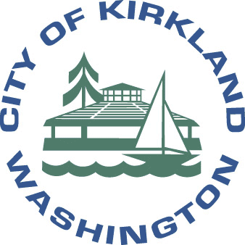
PUBLIC SAFETY ANNOUNCEMENT

From the City of Kirkland about

FIRE DANGER & EXTREME HEAT

With the state-wide drought emergency declared by Governor Inslee, the burn ban issued by the State Department of Natural Resources (DNR) for DNR-protected lands, the current dry conditions, and the recent high temperatures, there is concern about rising fire danger and the well-being of citizens. You are encouraged to be proactive in planning to stay safe in the heat and take appropriate measures to protect your health and homes. In hot and dry conditions, our city parks become susceptible to fires. When visiting parks, keep a look out for potential fire dangers and call 9-1-1 to report suspicious activity. The City of Kirkland reminds residents about the importance of preparing for all types of emergencies and disasters, including fire and extreme heat. For details on how to prepare, visit www.kirklandwa.gov/prepare.

Burn Bans
There are two different types of burn bans: Fire Safety and Air Quality. Air quality burn bans are issued and enforced by the Puget Sound Clean Air Agency (www.psecleanair.org) when air pollution levels rise to unhealthy levels, typically in colder fall and winter months. Fire Safety Burn Bans are issued and enforced by State, County or local jurisdictions when dryer weather conditions heighten the risk of wildfires. The City of Kirkland Fire Marshal’s Office does not allow open burning on public land or of yard debris and garbage. Permits for bonfires are not being issued during the current weather pattern. These restrictions do not include small recreational fires on private property where setbacks and safety measures are taken. Contact the City’s Fire Marshal’s Office at fireinspector@kirklandwa.gov or 425-587-3650 for more information.

Extreme Heat
Weather advisories and warnings are issued by the National Weather Service (www.weather.gov). The NWS cautions that during times of extreme heat, you should drink plenty of water, stay hydrated, and be in an air conditioned area, especially if you are susceptible to the heat. As temperatures in inside parked cars can rise very quickly to deadly levels, children and pets should never be left in one.

Public buildings such as Kirkland City Hall, the two city Community Centers (North Kirkland and Peter Kirk) and public libraries offer air condition are open during their regular business hours as places for you to stay cool. No food or beverage is provided.

Fireworks Ban in Kirkland
The City’s year-round fireworks ban prohibits the possession, sale and discharge of consumer fireworks. You are encouraged to watch the annual “Celebrate Kirkland July 4” fireworks display. Event information can be found at www.kirklandwa.gov; search “4th of July.” With this summer’s extreme heat, the danger of illicit fireworks puts people and property at increased risk.

Facebook: City of Kirkland Office of Emergency Management KirklandOEM
Twitter: City of Kirkland @kirklandgov Office of Emergency Management @oemkirkland

